EMPLOYEE MANAGEMENT APPLICATION

Technology used in this project:

1.java

2.Spring Boot

3.Java Servlet Page

WELCOME PAGE:

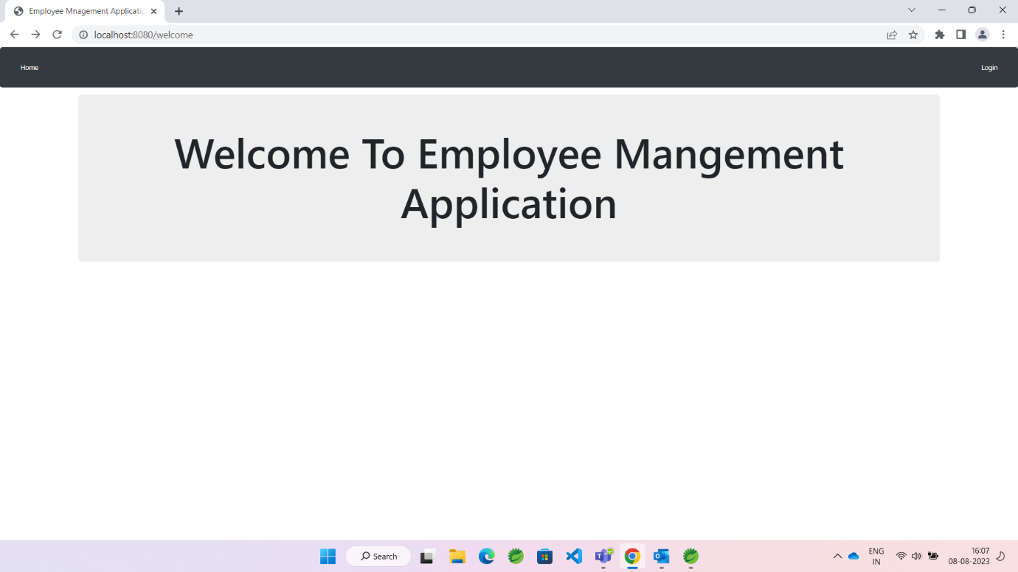

After entering into welcome we can login into our account by giving username and password.

LOGIN PAGE :

If the user is new to this application we can register with username and password .

REGISTRATION PAGE :

In registration form validations are added to all input text fields.

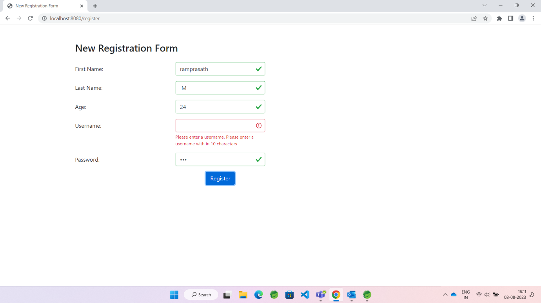

If we give wrong username and password it won’t enter into the home page .

HOME PAGE :

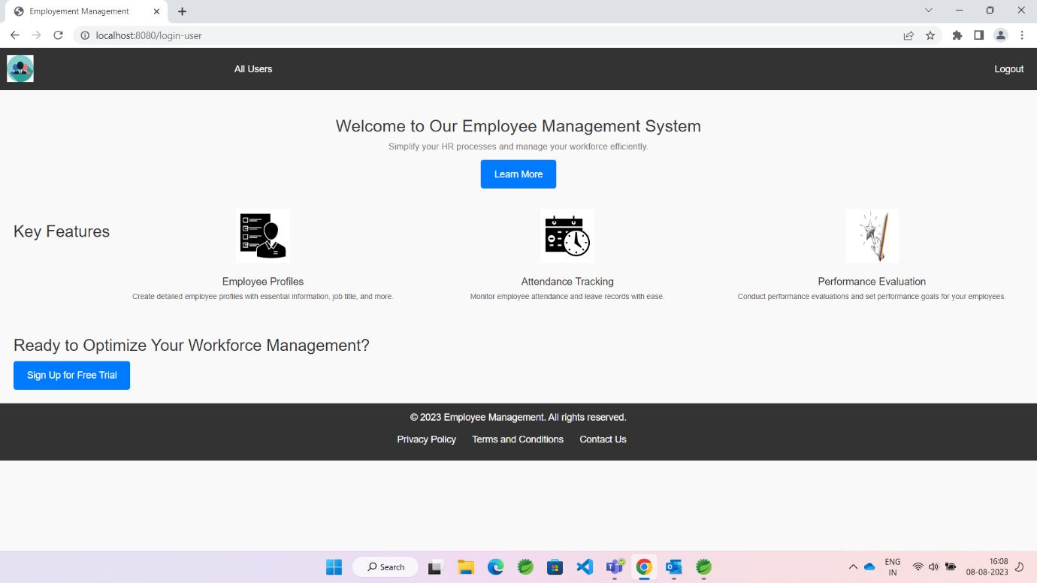

In this home page by clicking **all users** we can see the users who are registered in this application .

FEATURES ADDED TO THIS PROJECT :

ALL USERS PAGE :

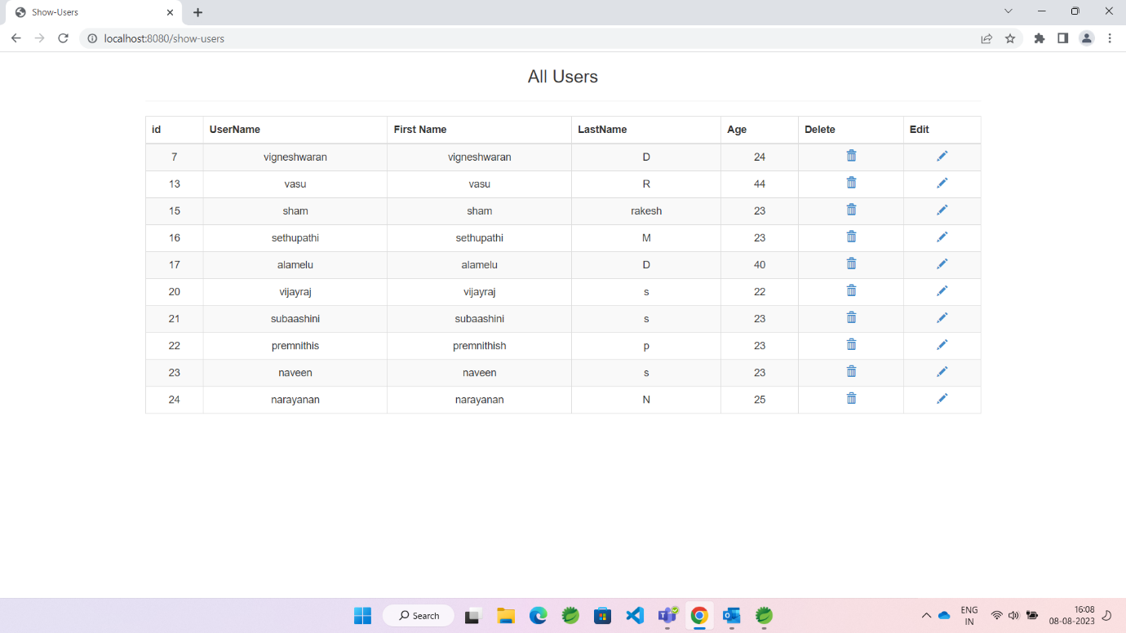

In all users page we can Edit and delete the users .

DELETING THE EMPLOYEE DETAILS :

ID 13 is deleted .

USERS-UPDATE PAGE :

If we need to change our details what we gave during new registration we can do in this update page and Bootstrap validation is used by using this we couldn’t update with empty updation form.

After doing all these operation by clicking Logout button we redirect to welcome page .